FACULTY EVALUATION
Programme Name: SEP Scale Masterclass Module 2 Tanzania (25th May 2026 - 29th May 2026)
Session: Social impact measures and planning
Faculty Name: Bernard Chege
No. of Respondents: 18
No. of Participants: 18
Evaluation Parameter | (%) Individual Score | (%) Programme Average
Punctuality (Commencement and Completion of Sessions) | 94 | 95
How well do you understand the core concepts presented? | 91 | 90
Rate your confidence in applying the new skills learnt | 91 | 87
Degree of Faculty preparedness for the sessions | 89 | 92
Content and methodology of the program | 91 | 90
Quality of class and group discussions | 89 | 90
The information presented in the course is relevant to my work (ministry) | 91 | 90
Average scores | 91 | 91

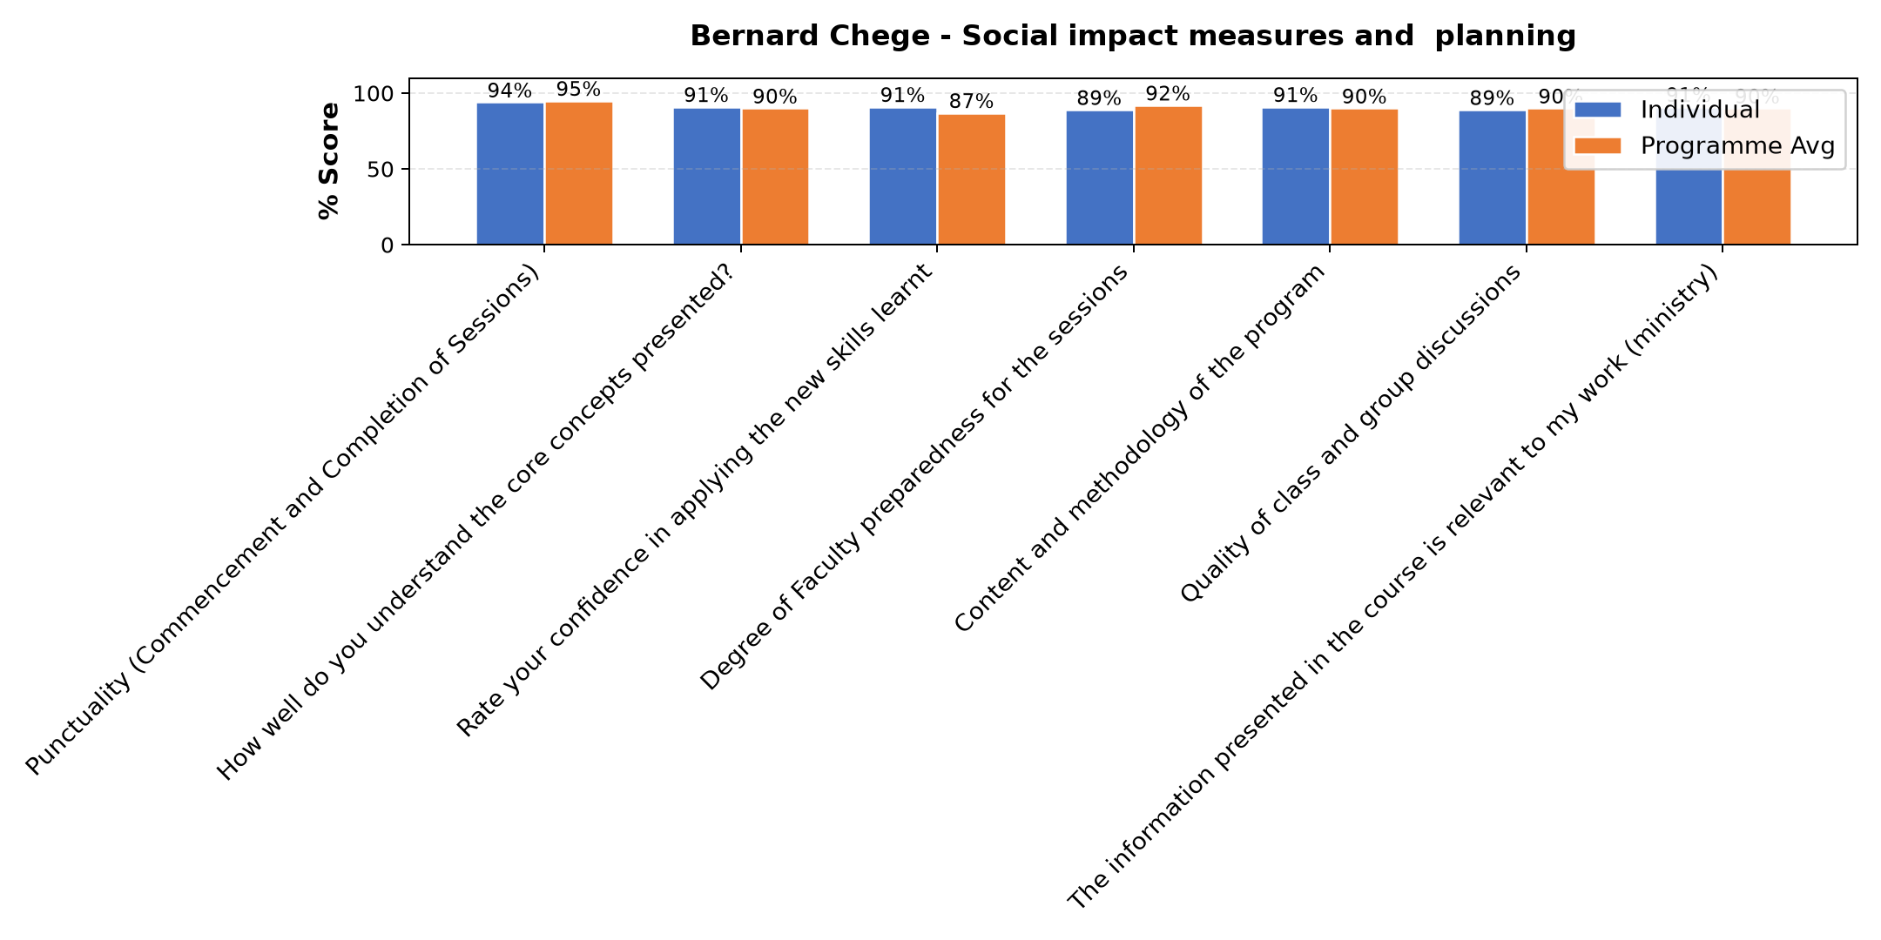

Comments & Feedback
- • Network
- • Good presentation
- • Some barriers that might prevent me from applying what I learned include limited financial resources, lack of enough time for proper planning and implementation, and difficulty in accessing accurate data for measuring social impact. In addition, limited support from stakeholders and challenges in monitoring and evaluating progress may also affect the application of the knowledge gained. However, with continuous learning, teamwork, and proper planning, these challenges can be managed effectively.
- • There is no barries in planning.
- • Internet problem
- • What have learnt have no any barrier it's my flexibility to cope well with team members to make sure that everything goes smoothly with the help of this knowledge gained
- • Capital
- • Environmental berriers
- • We need to do monitoring and evaluation to track changes. This needs human capital and funds which is scarce.
- • Network
- • Lack of propper equipments
- • Well done
SUBMITTED THROUGH:
SBS Evaluation Automation System

